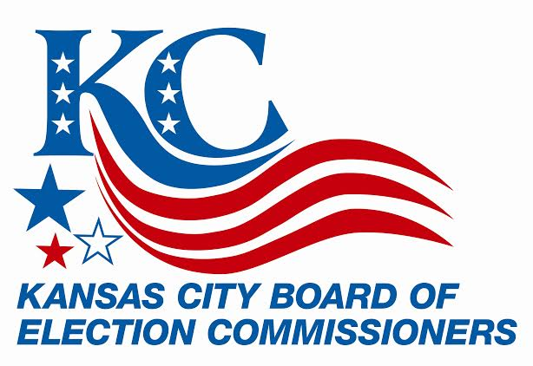

**FOR IMMEDIATE RELEASE:**

March 31, 2015

**FOR MORE INFORMATION:**

Shelley McThomas or Shawn Kieffer

816/842-4820

kceb@kceb.org

**Kansas City Election Board Readies Voters for April 7 Election**

**KANSAS CITY, MO. (March 31, 2015) –** The Kansas City Election Board (KCEB) announces details for the upcoming April 7 election. Following are the specifics to ensure that voters have the information needed to participate in Tuesday’s election.

**Date, Time, Place:** The election will be held Tuesday, April 7, 2015. Poll hours are 6:00 a.m. to 7:00 p.m.

**What’s on the Ballot:**

Mayor

City Council At Large (Districts 1, 2, 3, 4, 5, 6)

City Council (Districts 3, 4, 5, 6)

School District Directors (Hickman Mills, Raytown, Lee’s Summit)

School District Questions (Independence and Lee’s Summit)

City of Kansas City Questions (Park property and short-term loans)

A sample ballot is available online at www.kceb.org.

**Absentee Voting**: Walk-in absentee voting at KCEB will end on Monday, April 6, at 5:00 p.m. All mail-in absentee ballots must be received by the election office no later than 7:00 p.m. on Election Day.

In Missouri, voters need one of five reasons to vote absentee:

1) Out of town on Election Day

2) Religious restrictions

3) Incapacitated, hospitalized or homebound, or caring for a person who is confined

4) Employed by KCEB on Election Day

5) Incarcerated but eligible to vote.

**Polls**: Voters may find their polling location online at www.kceb.org by entering a last name and birth date in the *Check Your Voter Status* box, or by clicking on the *Poll Log* link on the KCEB homepage.

**New Polling Locations**:

Terrace Lake United Methodist Church (former poll: CrossPoint Community Church)

**Vote Centers:**

There will be 19 vote centers (combined polls) for the April 7 election.

**Election Notice Cards**: Cards were mailed to all active registered voters on Saturday, March 28. The polling location and address are printed on each election notice card. Voters whose polls have changed will be reminded on their card.

**Voter Identification**: Voters may present any of the following forms of identification:

1) Missouri or out of state driver’s license

2) Local, State or Federal government issued I.D. (employee, passport, social security card, military, etc.)

3) Missouri higher education I.D. (college or university)

4) Local election authority issued I.D.

5) Current bank statement, utility bill, government paycheck, or government document containing the voter’s name and current address

***Photo identification is not required to vote in Missouri***

**Additional Facts**:

Number of Polls: 135

Number of Precincts: 388

Total Registered Voters: 200,767

Estimated Election Cost: $465,420*

*as of 3/31/2015

**For additional information or assistance, please contact kceb@kceb.org or call (816) 842-4820.**

**FOLLOW KCEB ON:**

