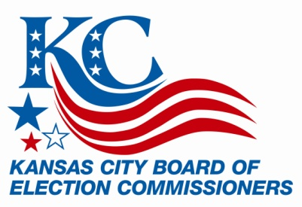

FOR IMMEDIATE RELEASE FOR MORE INFORMATION:
February 20, 2015 Shelley McThomas
Shawn Kieffer
816/842-4820
kceb@kceb.org

Absentee Voting Begins for April 7 Election

KANSAS CITY, Mo. (Feb. 20, 2015) – Tueday is the first day Kansas City voters can cast an absentee ballot for the April 7 municipal primary election.

Voters who qualify, may vote an absentee ballot in-person until 5 p.m. Monday, April 6 or by mail. Ballots cast by mail must be received by the Election Board no later than 7 p.m., Tuesday, April 7.

Voting will be available in-person at the Kansas City Election Board office, located in Union Station (30 W. Pershing Road) in Suite 2800 beginning Tuesday, February 24, 8 a.m. – 5 p.m. through Monday, April 6. The office will also be open for absentee voting on Saturday, April 4, 8 a.m. to noon.The deadline for military, overseas ballots to be returned via mail is April 10 at noon.

For mail-in voting, an application form must be submitted to KCEB. The form is available at www.kceb.org, or by calling KCEB’s absentee voting office at 816-842-4820 ext. 225.

Missouri election laws allow registered voters to vote absentee if they meet one of the following five requirements:
- Will be absent from their voting jurisdiction on Election Day
- Are incapacitated or confined due to illness or physical disability, or caring for an incapacitated person
- Are restricted by religious belief or practice
- Are employed by an election authority
- Are incarcerated, but have retained all voting qualifications
Voters will be narrowing down their selections for: mayor, city council at-large (Districts 1, 2, 3, 4, 5 and 6), city council (Districts 3, 4, 5, and 6), school district director (Hickman Mills, Raytown, Lee’s Summit), 2 school district questions (Lee’s Summit, Independence), and 2 City of Kansas City questions. A Sample Ballot is available at www.kceb.org.

The polls will be open from 6 a.m. to 7 p.m. on Election Day, Tuesday, April 7.

- more -
New residents who have moved into Kansas City must register by March 11 in order to be eligible to vote in the April 7 primary election. Voters who have moved since they last voted, should submit a change of address form by mail (30 W. Pershing Road, Suite 2800, Kansas City, MO 64108), fax (816-221-3348) or in person (KCEB Office, Suite 2800) to KCEB to be assured of receiving a new voter ID card and their new polling location.

Kansas City has 202,613 registered voters.

For additional information or assistance, please contact kceb@kceb.org or call (816) 842-4820.

Kansas City Board of Election Commissioners
30 W. Pershing Road, Suite 2800, Kansas City, MO 64108

FOLLOW KCEB ON:

