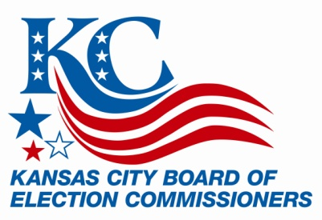

FOR IMMEDIATE RELEASE FOR MORE INFORMATION:
May 18, 2015 Shelley McThomas
Shawn Kieffer
816/842-4820
kceb@kceb.org

Absentee Voting Begins for June 23 Election

KANSAS CITY, MO. (May 18, 2015) – Absentee voting for the June 23 municipal general election began last week, May 12, for Kansas City voters.

Voters who qualify, may vote an absentee ballot in-person until 5 p.m. Monday, June 22 or by mail. Ballots cast by mail must be received by the Election Board no later than 7 p.m., Tuesday, June 23.

Voting is available at the Kansas City Election Board Administrative Office, located in Union Station, Suite 2800 (30 W. Pershing Road) 8 a.m. – 5 p.m. through Monday, June 22. The office will also be open for absentee voting on Saturday, June 20, 8 a.m. to noon. Please be aware that absentee voting is now located in Suite 2800 and is no longer in Suite 610.

For mail-in voting, an application form must be submitted to KCEB. The form is available at www.kceb.org, or by calling KCEB’s absentee voting office at 816-842-4820 ext. 224.

Missouri election laws allow registered voters to vote absentee if they meet one of the following five requirements:
- Will be absent from their voting jurisdiction on Election Day
- Are incapacitated or confined due to illness or physical disability, or caring for an incapacitated person
- Are restricted by religious belief or practice
- Are employed by an election authority
- Are incarcerated, but have retained all voting qualifications
Voters will be deciding on: Kansas City Mayor, City Councilmember members, and Circuit Court Judges for the Sixteenth Judicial Circuit.

- more -

The polls will be open from 6 a.m. to 7 p.m. on Election Day, Tuesday, June 23.

New residents, or those not registered, must register by May 27 in order to be eligible to vote in the June 23 election. Voters who have moved since they last voted, should submit a change of address form by mail (30 W. Pershing Road, Suite 2800, Kansas City, MO 64108), fax (816-221-3348) or in person (KCEB Office, Suite 2800) to KCEB to be assured of receiving a new voter ID card and their new polling location.

Kansas City has 203,572 registered voters.

###

For additional information or assistance, please contact kceb@kceb.org or call (816) 842-4820.

Kansas City Board of Election Commissioners
30 W. Pershing Road, Suite 2800, Kansas City, MO 64108

FOLLOW KCEB ON:

